**MODULE OF MEDIA STREAMING AND IT’S DISCRIPTION:**

**Module Name: MediaStreamModule**

**DISCRIPTION**:The MediaStreamModule is a flexible and durable software element created to simplify video streaming across multiple platforms and gadgets. It gives programmers the tools and features they need to integrate media streaming capabilities into their applications, whether they're using them for on-demand music playback, live video broadcasts, or other multimedia content.

**KEY FUTURE:**

**Integration of Media Sources:** The module allows for the integration of a variety of media sources, including local files, web broadcasts, and cloud-based storage services. This versatility makes it simple to access different media resources.

**Support for Streaming Protocols:** MediaStreamModule supports well-known streaming protocols like HTTP Live Streaming (HLS), Dynamic Adaptive Streaming over HTTP (DASH), Real-Time Messaging Protocol (RTMP), and others to ensure compatibility with a variety of streaming services and devices.

**Adaptive Bitrate Streaming:** To offer a fluid streaming experience, the module has options for changing bitrate streaming. It automatically changes the media stream’s quality based on the viewer’s network setup to deliver the optimal playback experience.

**Cross-Platform Compatibility:** The module’s compatibility with a variety of platforms, such as web browsers, mobile devices (like iOS and Android), and desktop applications (like Windows, macOS, and Linux), allowing developers to reach a broad audience.

**Customization & Styling:** Developers can modify the player’s appearance and features to meet their application’s branding and user experience standards. There are options for playback behaviors, controls, and player skins.

**Analytics and monitoring:** MediaStreamModule offers fundamental analytics tools that let developers monitor viewer demographics, user activity, and streaming effectiveness. The delivery of content and the user experience are both improved by this information.

**Security and DRM:** The protection of material from unauthorized access and infringement is ensured through Digital Rights Management (DRM) support and other robust security measures.

**Scalability:** Because the module is designed to handle high traffic and scalability requirements, it is suitable for both small-scale applications and large-scale media platforms.

**Documentation and Support:** Detailed documentation and developer support tools are provided to developers so they may integrate and debug the module into their applications.

**Community and Updates:** The module benefits from a thriving development community and regular updates, which ensure that it keeps up with the evolving best practices and standards for video streaming.

**DIAGRAM OF MEDIA STREAMING:**

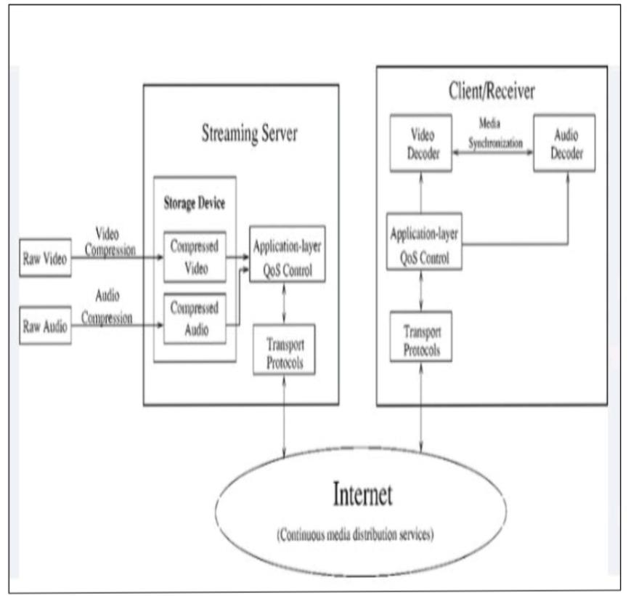

**DATASET OF MEDIA STREAMING:**

**User Data:**

User ID

Username

Email Address

Subscription Type (e.g., free, premium)

Subscription Start Date

Subscription End Date

Payment Information (if applicable)

**Content Data:**

Media Title

Media Type (e.g., movie, TV show, music)

Genre

Release Date

Duration

Description/Summary

Thumbnail URL

Media File URL

Rating/Reviews

Language

Director/Artist

Cast/Crew

**User Interactions:**

Date and Time of Media Playback

Duration of Playback

Device Used

User Ratings

User Reviews/Comments

**Streaming Quality:**

Video Resolution

Bitrate

Buffering Time

Playback Errors

**Recommendations:**

Recommended Media

Click-Through Rate on Recommendations

Effectiveness of Recommendations (e.g., user engagement after recommendations)

**Performance Metrics:**

Server Response Time

Concurrent User Count

Bandwidth Usage

Geographic Location of Users

**User Preferences:**

User’s Watchlist

Favorite Genres

Search Queries

Watch History

**User Demographics:**

Age

Gender

Location

Device Type

Internet Connection Speed

**Content Licensing:**

Licensing agreements with content providers

Expiry dates for licensed content

**Security and Access:**

Login Attempts

Account Activity Logs

IP Addresses

**PROPERTIES OF MEDIA STREAMING**

**Content metadata:** Datasets usually include metadata about the media content, such as names, descriptions, genres, release dates, and more. The users gain from these meta-data.

**User Data:** User-related information, such as preferences, viewing habits, and demographic information, is helpful for tailoring content to individual users and altering recommendations.

**Streaming Analytics:** Real-time streaming metrics, such as the quantity of viewers, their geographic locations, and the devices they use, can be recorded in databases. Using this information, the service’s performance may be monitored, and adjustments can be made as needed.

**Content Delivery Optimization:** Datasets are used by media streaming services to improve content delivery, or content delivery optimization. Content delivery networks (CDNs) use data to identify the ideal server locations and delivery routes in order to provide content with the least amount of delay and buffering.

**Service quality (QoS):** Stream quality information, such as video bitrates, resolution, and buffering times, may be included in datasets. This data makes it easier to identify and fix QoS-related issues.

**Resource Allocation:** Cloud computing resources are allocated using dataset insights. These decisions can be made more dynamically with the help of datasets, for example, by determining when to deploy more server instances to handle rising demand during periods of peak usage.

**Security and Access Control:** Datasets also record security and user access data. This ensures that only authorized users may access certain material and aids in identifying and stopping unauthorized access or infringement.

**Content Licensing and Rights Management:** Datasets contain details about content licensing contracts, rights holders, and usage restrictions, helping to ensure compliance with legal duties and copyright regulations.

**Adaptive Streaming:** Adaptive streaming methods use datasets to adjust the stream’s quality in real-time to the viewer’s network circumstances, device capabilities, and history of buffering.

**Machine Learning and AI:** Datasets are frequently used to train machine learning models for a number of purposes, such as content recommendation, content classification, and user behavior prediction.

**PREPROCESSING OF MEDIA STREAMING :**

**Encoding/Compression**: Media files are generally compressed to lower their size while keeping acceptable quality because they are frequently huge. There are several widely used codecs, including H.264 for video and AAC for audio.

**Segmentation**: The media content is segmented into manageable, bite-sized portions or segments. This is essential for adaptive streaming, which can deliver varied quality levels depending on the network conditions of the viewer.

**Format conversion**: Ensure that all media files are converted to the proper format for streaming. MP4 and HLS for adaptive streaming, as well as MP3 for audio, are common formats.

**Content Encryption:** Prevent illegal access to the content by encrypting it. Common encryption techniques include DRM (Digital Rights Management) programs or HLS AES-128 encryption.

**Integration of a material Delivery Network (CDN):** Set up a CDN to distribute material closer to end users, lowering latency and improving streaming performance.

**Adaptive Bitrate Streaming (ABR):** Implement adaptive bitrate streaming (ABR) protocols like HLS (HTTP Live Streaming) or MPEG-DASH to dynamically alter the stream’s quality dependent on the viewer’s network circumstances.

**Buffering and catching**: Implementing buffering and caching techniques will shorten load times and enhance the overall streaming experience.

**Quality control:** Monitoring and evaluating the media streams' quality on a regular basis will help to guarantee that they adhere to the appropriate criteria. Automated testing and quality checks on various hardware and network configurations may be required for this.

**Content Delivery Optimization**: Choose the right streaming servers and make sure redundancy and failover systems are in place to optimize content delivery.

**Ad Insertion**: If necessary, place advertising at specific points in the stream. Utilizing ad insertion technologies like VAST or VPAID as well as integration with ad networks may be necessary for this.

**Preloading of Content:** Preloading some of the content will improve user experience by lowering startup latency and buffering.

**User Authentication**: Use systems for user authentication to restrict access to authorized users or manage access to premium content.

**FEATURE EXTRACTION OF MEDIA STREAMING:**

**Audio Feature Extraction:**

**Spectral features:**Chroma features, mel-frequency cepstral coefficients (MFCCs), and spectrograms are a few examples of spectral features that describe the spectral properties of audio sources.

**Temporal Features:**Audio’s temporal characteristics can be learned from features like zero-crossing rate, energy, and tempo.

**Statistical Features:** Descriptive statistics like mean, variance, and skewness can represent the statistical distribution of audio signals.

**Video Feature Extraction:**

**Motion Features**: Optical flow, motion vectors, and frame differences help capture motion information in video streams.

**Colour Histograms**: Colour distribution within frames or video segments can be described by extracting colour histograms or colour moments.

**Texture Features**: Texture patterns in video frames can be captured using features like Gabor filters or local binary patterns (LBP).

**Metadata Extraction**: For effective media streaming and synchronization, metadata extraction is necessary. Examples of this kind of information include video resolution, frame rate, codec information, and timestamps.

**Content-based feature extraction:**  Analyzing the content itself to identify objects, people, or particular situations might be essential for content recommendation or indexing. This is known as content-based feature extraction.

**Quality Evaluation**: Features relating to bit rate, packet loss, jitter, and frame rate can be extracted in order to evaluate the media stream’s quality. For adaptive streaming algorithms to alter the streaming quality in real-time based on network conditions, this information is crucial.

**Real-Time Processing:** To enable activities like content moderation, live transcoding, or audience analytics, feature extraction must be carried out effectively in real-time for live streaming.

**Adaptive Streaming:** To enable adaptive streaming systems to choose the proper quality level for each user and adapt on-the-fly, features pertaining to network conditions, device capabilities, and user preferences are extracted.

**Security and material Protection**: By examining watermarks or fingerprinting methods, feature extraction can be utilized to spot illicit material distribution or copyright infringement.

**CONCLUSION:**

In conclusion, video streaming in the cloud computing environment has many benefits, including scalability, cost-effectiveness, and accessibility throughout the world. It helps organizations and people to easily distribute material to a large audience while lowering infrastructure expenses. However, to guarantee a successful and secure media streaming experience in the cloud, it’s imperative to take into account elements like security, data privacy, and network dependability. Cloud-based media streaming is projected to become more important in the digital environment as technology progresses.